**Q1)**

**Yes**, a **friend function can** be used to overload an operator that modifies the invoking object. The reason is that a friend function can access the private and protected members of the class, which allows it to modify the left-hand operand.

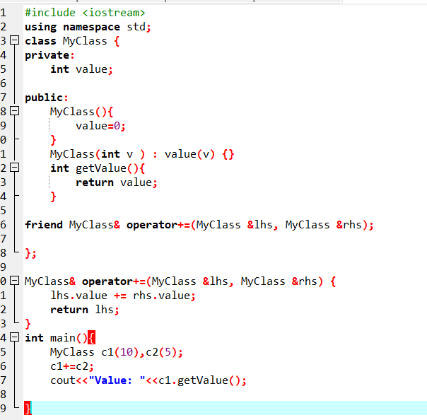



Q2)  
Yes, a **friend function can be used** to overload an operator when one operand is a **primitive data type**(e.g., object + int). This is because **friend functions take both operands explicitly.**

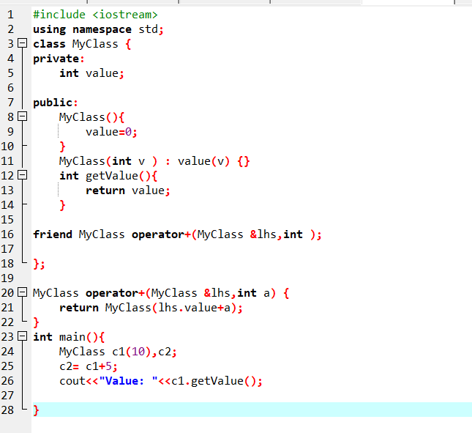



Q3)  
Friend Function cannot access non static member without the object because **It requires an object**because**friend functions do not have access to**this**pointer,** unlikemember functions**.**

